SIT223 Project 1

The form will consist of a few different attributes to allow users to enter in information that relates information back to a database that checks against a list of different entities to find whether the users vehicle has an Airbag recall.

The form element within the website will have different containers that will allows different types of inputs for the different entry fields.

The different entry fields are as follows:

* Car manufacturer
* Car model
* Car year

These fields will allow for the database to define what vehicle the user has and will report back whether their vehicle is found to be as a vehicle that has an airbag issue. The user will be notified that they are at risk and they should get their airbag changed as soon as possible

The image below shows the final version of the input fields and what it will look like alongside what kind of inputs will be needed to fulfil the query conditions, once these are all filed correctly the user will be notified whether they need to replace their airbags.

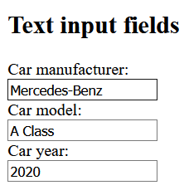

Below is shown the necessary HTML code needed to show the form online, this form accepts users inputs and submits them in reference to their ID’s and checks them against a predefined list of faulty cars.

